https://roadmap.sh/typescript
Good “everything” resource on TypeScript (Thanks Jon S. 2025)
Click the boxes to learn more about certain topics!
What is TypeScript?
- TypeScript is the language we’ll use to provide functionality to our React front ends.
- “TypeScript is a superset of JavaScript”.
  - SuperSet - A programming language that contains all the features of another language, plus extra features added on.
  - So TypeScript is like JavaScript, with more strictness & OOP principles built on.
    - Specifically type safety. “Type”script.

- All valid JavaScript (JS) is valid TypeScript (TS). But the reverse is not always true...
  - TS must be “transpiled” into JS for a browser to read. Browsers do not have built-in support for TS.
    - React will transpile our TS for us :)
- “Transpilation is a specific term for taking source code written in one language and transforming it into another language with a similar level of abstraction.”
  - So, while Java COMpiles into bytecode, TS TRANSpiles into JS.

- We can transpile a Typescript file from the command line using:
  - tsc myFile.ts
This will create the appropriate transpiled JS file that you can run in your browser.
- TS is open source, object oriented, strongly typed, and mostly strictly typed.
  - Open source - basically just means free to use
  - OOP - it supports classes, inheritance, interfaces
  - Strongly Typed philosophy - when you declare a variable, you should declare a type as well.
  - Strictly Typed - when you declare a variable, you can’t change it’s type without some extra steps. No implicit type coercion!
    - Strong/Strict typing isn’t required these days, but still encouraged
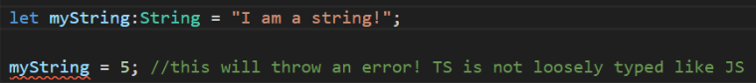

TypeScript Data Types
- We tend to only use let or const. var can be used but it’s less common.
Note – we can declare object variables with “const”, which makes the variable reference immutable, and “as const”, which makes the values immutable
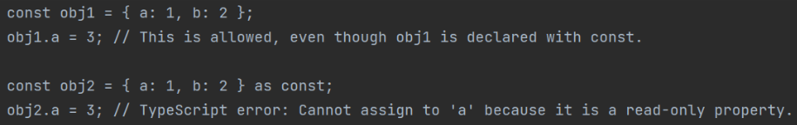
With just const, the values in this array can still change
After adding “as const”, we can’t change the array’s values. It’s read only!
- What if we have something like const a = 5?
- Then we wouldn’t be able to change the value. Const lets us change OBJECT or ARRAY values, as long as we don’t change the reference
TypeScript has all the basic datatypes of JS... Plus, way more:
- Any - Because TS is transpiled into JS (which is loosely typed), sometimes we need the ability to declare a variable without a specific type.
- It can be “any” type it needs to be. This makes our code more flexible!
- ...At the cost of type safety. It’s better to avoid using this datatype. Sometimes you can’t though.
- Unknown – Similar to “any”, but used when you don’t know the data type that may be used. This is more type safe!
- The main difference is that you can’t perform operations on unknown types until you’ve done a type check (which makes it “safer” than the any datatype)
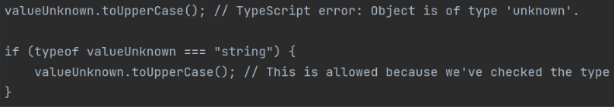
So unknowns can only be used within blocks that type check them first
- Arrays - Arrays in TS are typed like Arrays in Java. So, only values of the declared Array type are acceptable, and they’re dynamic in size.
- Union types: These allow you to specify that a value can be one of several types. You can use the | operator to combine multiple types into one.
- 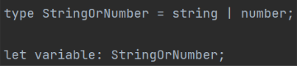

- Tuples: A tuple type is like an Array that has a fixed number of elements it contains, and it specifies which types it contains at specific positions.
- They are a way to represent a record, or some collection of values that are related in some way. Like a very strict array
- 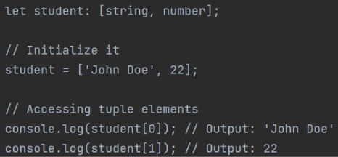
- We’ve actually used tuples plenty of times. The useState hook is a tuple! (I never really make my own tuples though)

- Enums: These allow us to define a set of named consts. Enums have some advantages over regular variables:
- They make it easier to document the intent of a class
- Gives a good idea of what the class does
- Their values cannot change
- They support type safety
- There are two types we can use:
- String enums store values as string literals
- 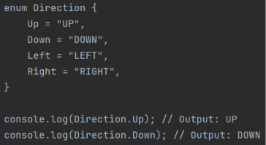
- Numeric enums store values as numbers. By default, they start from 0 but you can set the value of the first item and the rest will increment from there.
- 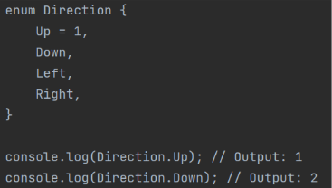

- Never & Void: These are function return types
- Void: For a function that doesn’t return anything
- Never: For a function will never complete because it “raises” (throws) an error.
- You’d only really use this if you want to create a custom error.
- The severity of the error is up to you! Do you want it to be handled? Or do you want it to crash your code?
- It accomplishes the same thing as making a custom Exception in Java.
- Functions can return any data type you want of course!
Running a TypeScript file
- Disclaimer – we're not going to run TS outside of Angular. But here’s how you would do it:
- First, you need Node.js installed... Ok good you already have it
- Install TypeScript using Node Package Manager (npm - included with node.js)
- 
- Write a TS file!
- 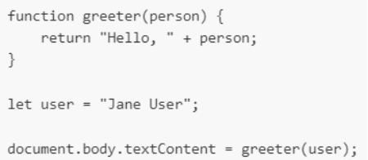
- Run it from the command line using the tsc command (TypeScript Compile) to transpile your TS into JS, that you can then run with node.
- 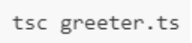
- (followed by "node greeter.js”)

TypeScript Classes
- TS is OOP - so it has support for Classes. It uses the “class” keyword to declare them, then the “new” keyword to create an object of that class.

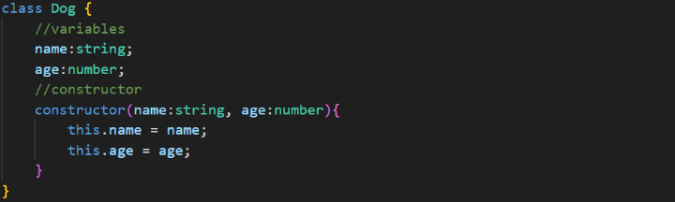

- TS has inheritance just like in Java and uses the “extends” keyword in the same way.
- We also have interfaces, which behave more like Java Model Class in our React projects. They essentially let us define custom datatypes.
- 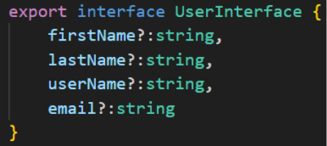
- We can set fields to be optional with “?”

TypeScript Functions
- TS functions are like any other function we’ve seen in JavaScript, except we specify a return type if we intend to return something.
- 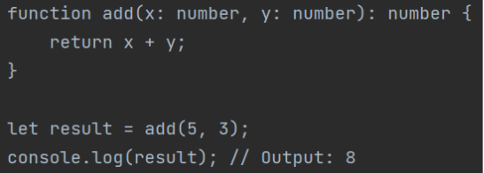

TypeScript Decorators
- Decorators are essentially the same as annotations in Java. They use the @ symbol and provide additional functionality to your code.
- Decorators can be attached to classes, functions, properties, parameters, etc.
- We may see some of these working with React
- Examples include:
- @readonly
- @sealed – seals a class, prevents new properties from being added to it
- @log – logs a method’s name and arguments whenever it’s called
- More you can look into
Generics
- Typescript has generics just like Java. They’re pretty much the same in syntax, behavior, and use case – they allow you to write reusable, flexible, and generalized types and functions.
- 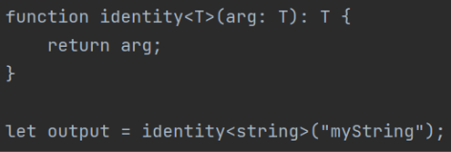
- In this example, we defined a function with a Generic type, allowing us to use any type of datatype when invoking the function
- We can also declare Array Generics when the type of Array is known.
Casting
- Typescript has casting just like in Java, where we can explicitly change a variable’s datatype. Typescript lets you do it in two ways:
- Angle bracket syntax
- 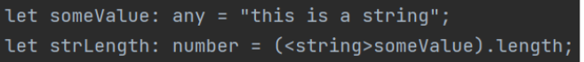
- “as” syntax
- 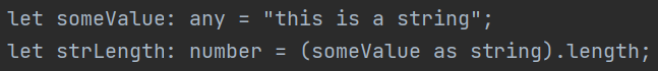

Type Guards
- Type guards in TypeScript are a way to discern the datatype of a variable, before performing type-specific functionalities. They are a design pattern used by developers, and a built-in TS construct.
- What for?? Type guards are useful in scenarios where the type of a variable could be one of several types (a union type? Any? Unknown?), and you want to perform different operations depending on the actual type of the variable at runtime.
- We can use the typeof and instanceof keywords to make type guards.
- 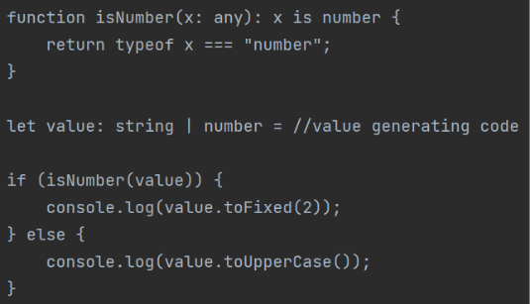
In this example, we write a type guard for number type, generate a string OR a number from some code, and then use our type guard to determine datatype-based control flow
- Note the ‘x is a number” return type – this is essentially a boolean
- Fun fact – this is how the “unknown” datatype works. You need to use a type guard before performing operations on an unknown.

Typescript Configuration
- TypeScript configurations are generally set in the aptly named tsconfig.json files.
- The tsconfig.json file is used to specify the root files and the compiler options. It's a crucial part of configuring your TypeScript projects
- NOTE - we often don’t need to change the auto-generated configs at all.
- You may notice tsconfig.app.json and tsconfig.node.json in your Angular projects
- App is for client side, node is for server side. So app is the one that’s relevant to us
- Compiler options are the many many many settings we can set within tsconfig.json
- Here’s a good link for a reference on the config options in tsconfig https://www.typescriptlang.org/tsconfig
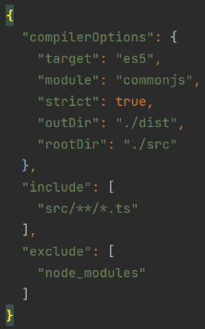 example tsconfig.json
- If you remember only two compiler options, remember strict and target:
- Strict: This enables a wide range of type checking behavior that results in more type-safe programs. When strict is true, it enables all the options listed below (plus some more):
- noImplicitAny: This raises an error on expressions and declarations with an implied any type.
- with explicitly declared any types, it’ll just yell at us
- strictNullChecks: This enables strict null checks – no nulls allowed in things like expressions.
- strictFunctionTypes: This enables strict checking of function types.
- strictPropertyInitialization: This ensures non-undefined class properties are initialized in a constructor.
- alwaysStrict: This parses in strict mode and emits "use strict" for each source file.
- Target: This specifies the ECMAScript target version. The default is ES5. In a React project, the default is “ES2020” (as of Feb 2025)
- What is ECMAScript again? It’s basically the version of JavaScript (and by proxy, TypeScript) we’re using. It’s like Java versions.
- Module: Sets the module system to be used. Setting it to “commonjs” will compile your TypeScript into standard JavaScript modules (transpilation!).
- React will often have this set to “esnext”, AKA the latest version of ECMAscript
- In the example above, you’ll also see include and exclude values. These are used to specify which files the TypeScript compiler should include or exclude when it compiles your TypeScript code.
- Include contains the files/directories you want to be compiled
- Exclude contains the files/directories you DON’T want to compile

- Also, do you remember the tsc command from the very beginning of our TS notes? The command we use to compile TS files? Well, it works by looking for tsconfig.json files!!
- Each folder containing a tsconfig.json file will be treated as its own project by tsc, and be compiled according to the configs found in the tsconfig file.
- If no tsconfig.json is found, default configs will be used instead

Utility Types
- Utility types provide convenient ways to transform types from one form to another. They are essentially a set of generic types that help you accomplish certain type manipulations.
- Field trip to the curriculum to see some of the different utility types. Some that may be easy to remember:
- Awaited
- Readonly
- Record

